Name: Phạm Chí Bằng

Student ID: 20235477

**Use-case diagram and class diagram**

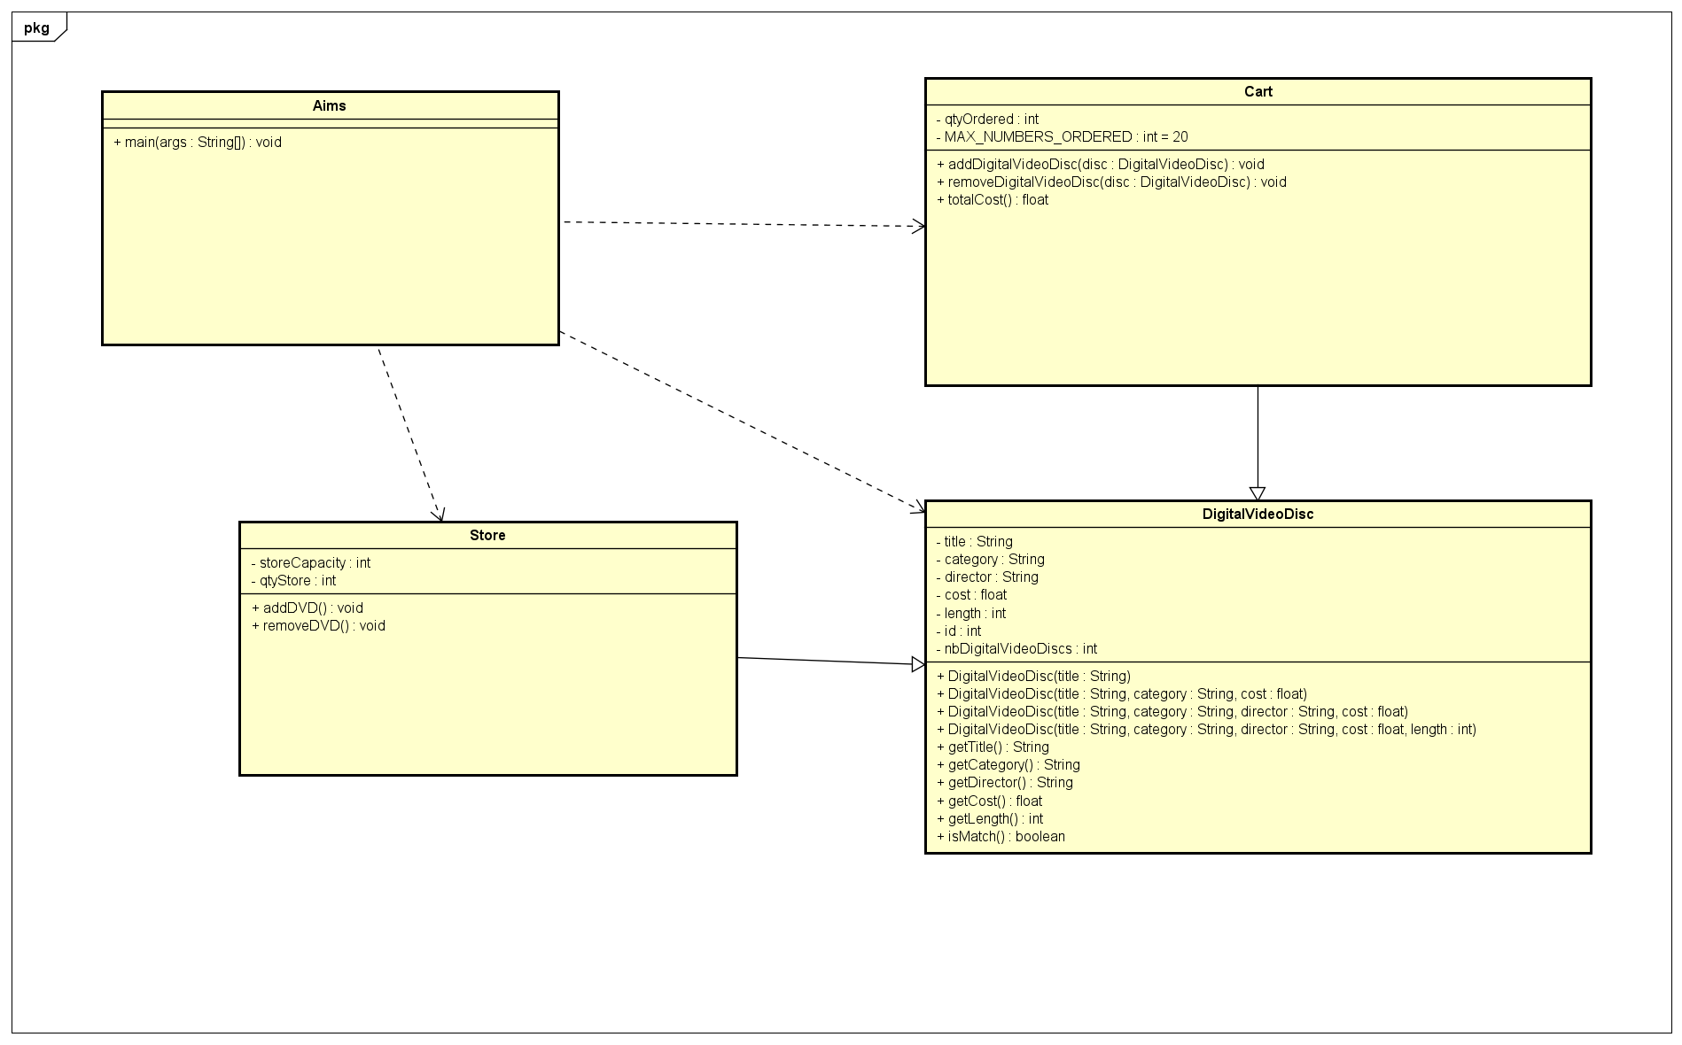

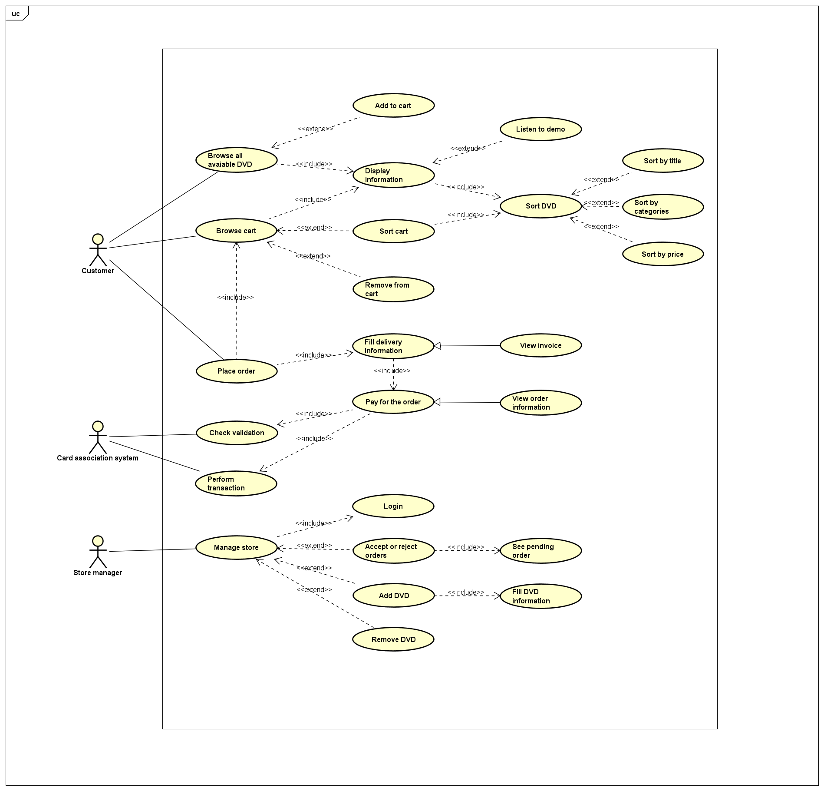

**Working with method overloading**

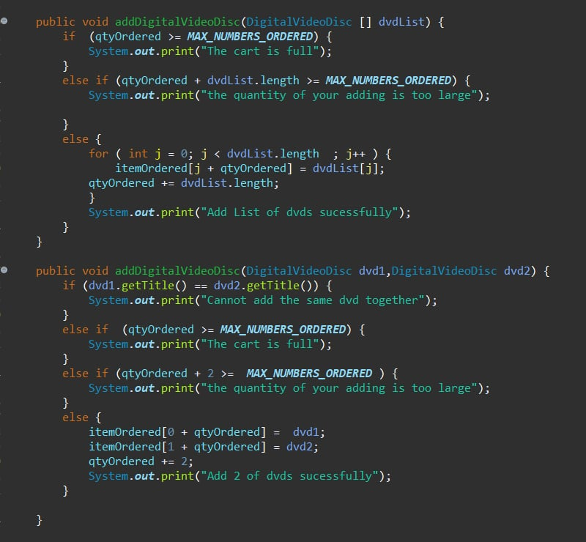

- Try to add a method addDigitalVideoDisc which allows to pass an arbitrary number of arguments for dvd. Compare to an array parameter. What do you prefer in this case?

I would prefer array parameter as it is easier to add a certain amount of DVD

**Passing parameter**

True swap method:

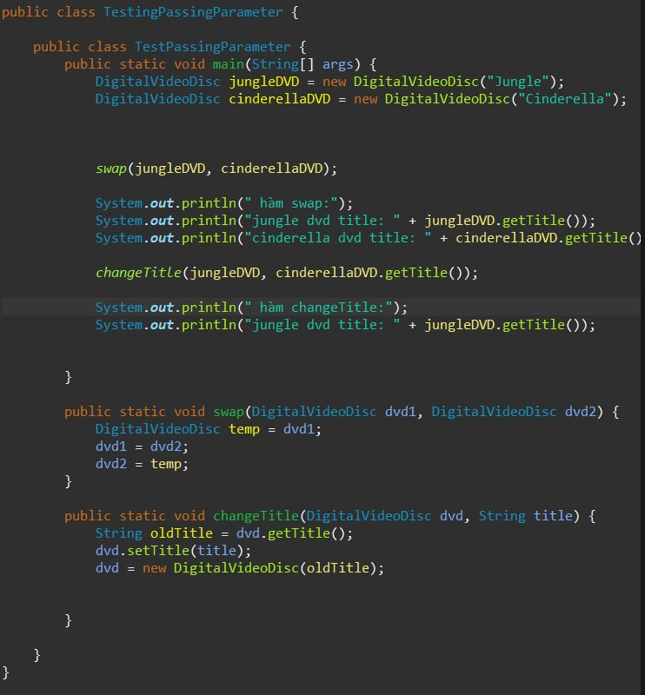

* Is JAVA a Pass by Value or a Pass by Reference programming language?

JAVA is a pass by value programming language. The dvd1 and dvd2 in the method are copies of the reference to the original dvd1 and dvd2

* After the call of **swap(jungleDVD, cinderellaDVD)** why does the title of these two objects still remain?

The dvd1 and dvd2 in the method are copies of the reference to the original dvd1 and dvd2, therefore swap only swap the copies, not change the original object

* After the call of **changeTitle(jungleDVD, cinderellaDVD.getTitle())** why is the title of the JungleDVD changed?

changeTitle take the address and modify title at that address, therefore it also change the original dvd

**Debug screenshot**

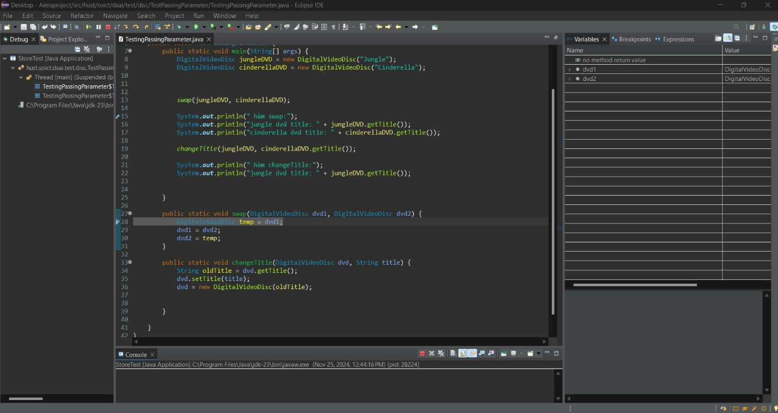

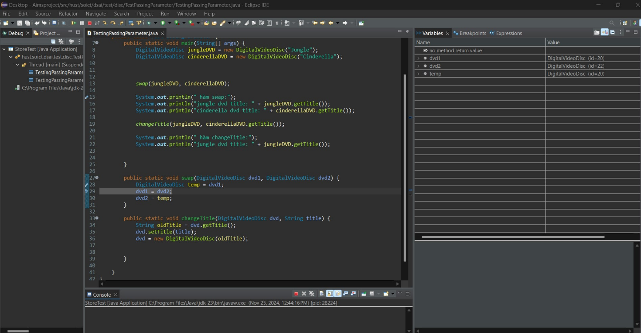

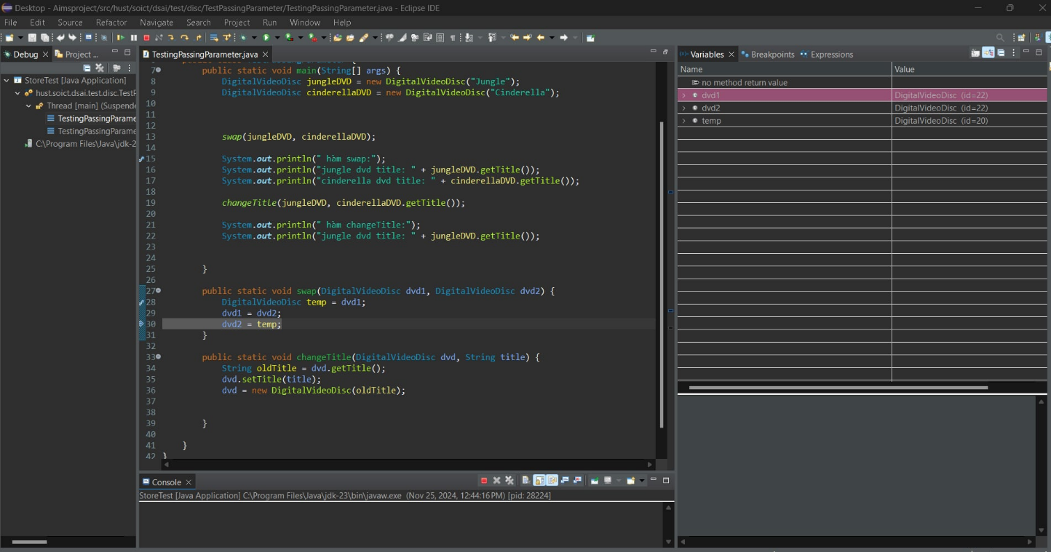

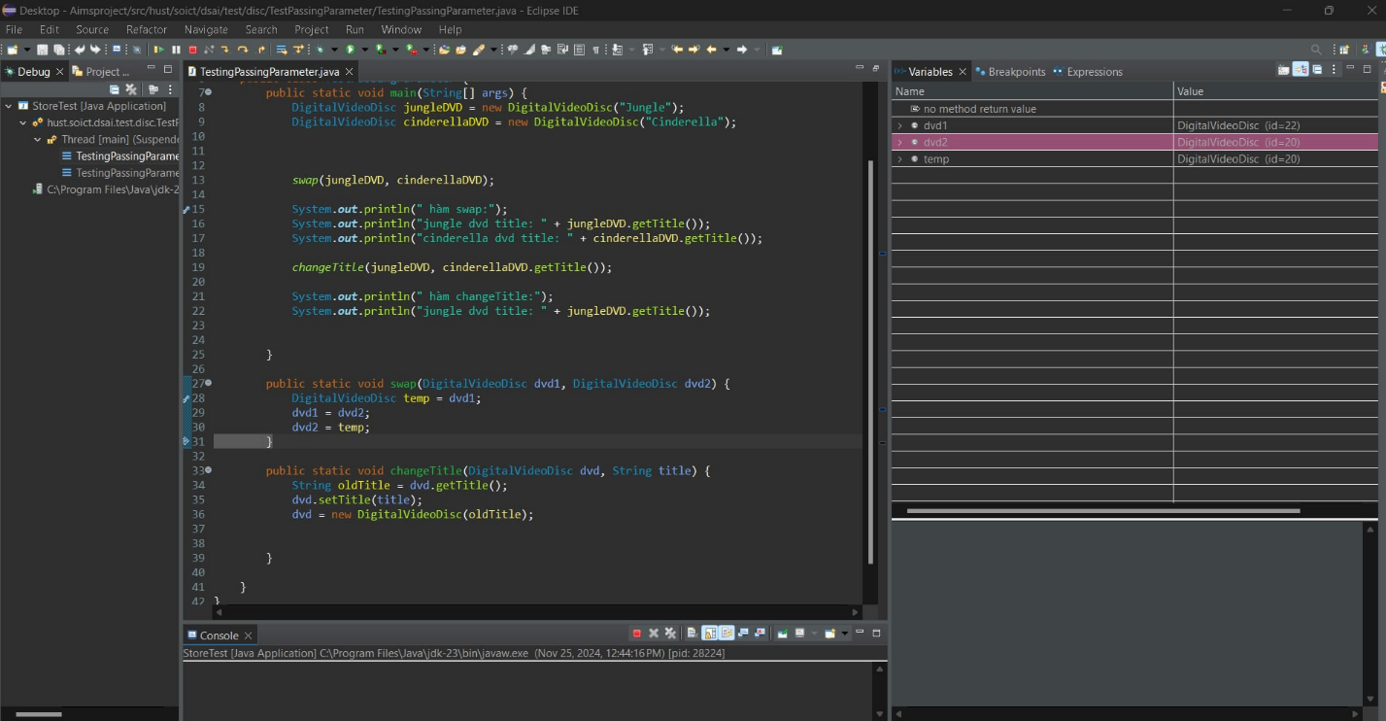

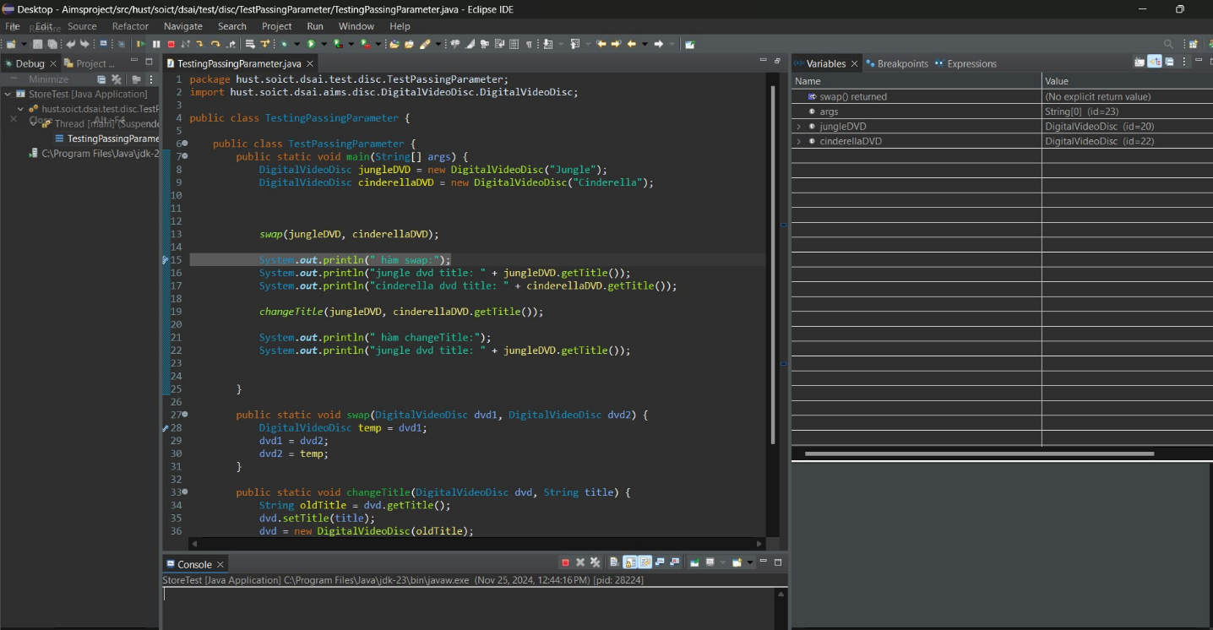

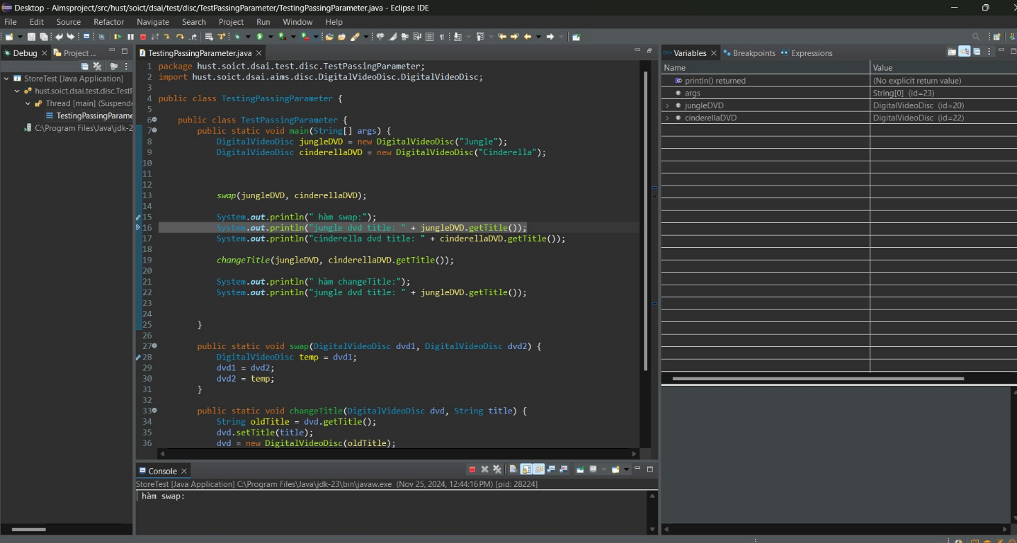

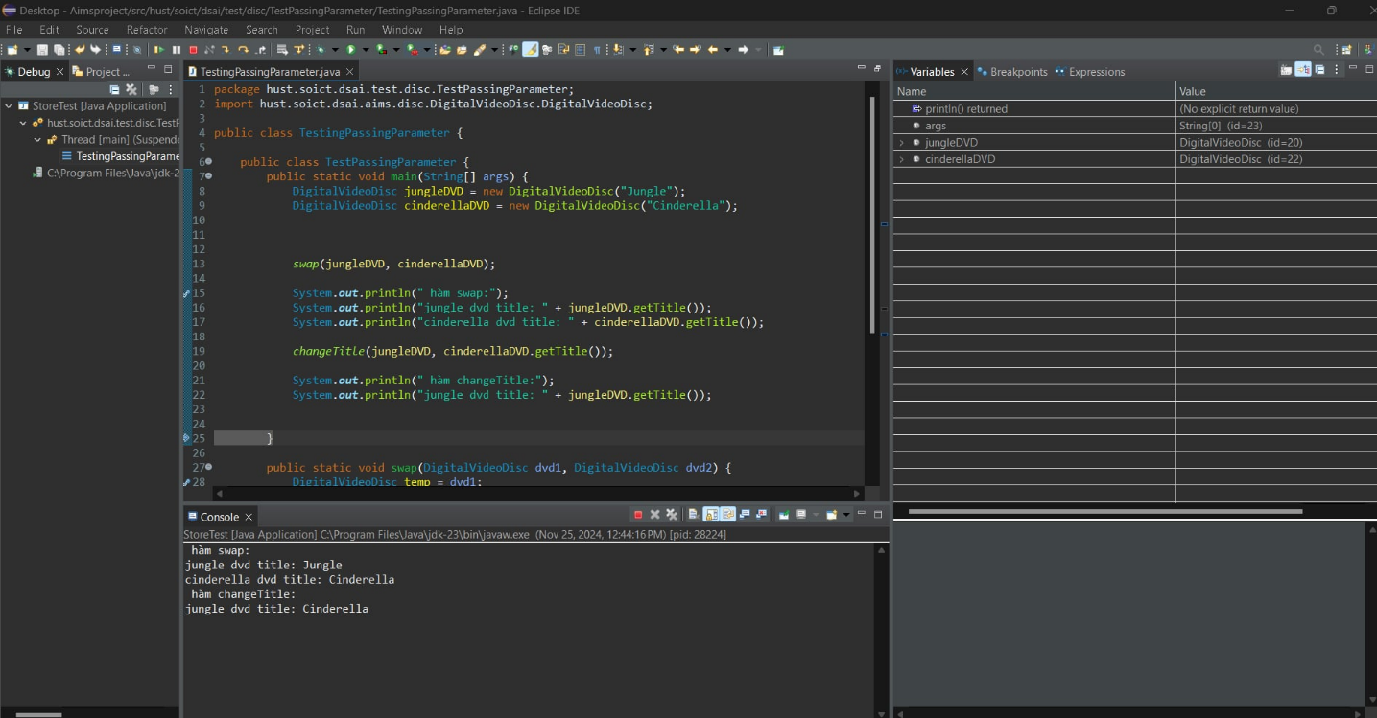

**Classifier Member and Instance Member**

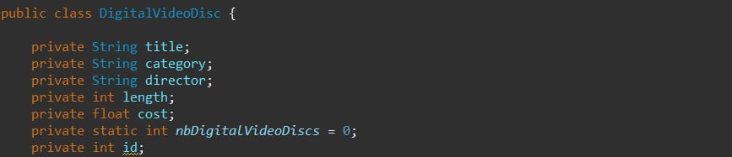

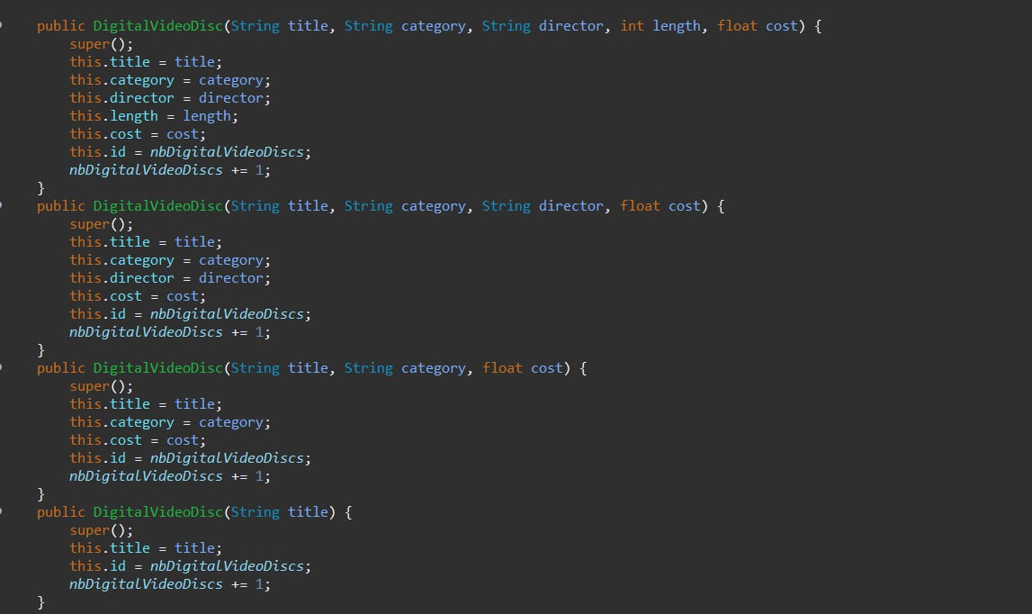

**Open the Cart class**

* Write a toString() method for the DigitalVideoDisc class. What should be the return type of this method?

It should be String

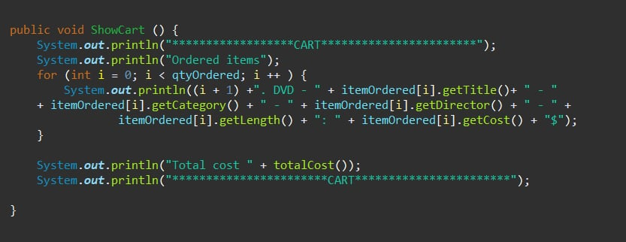

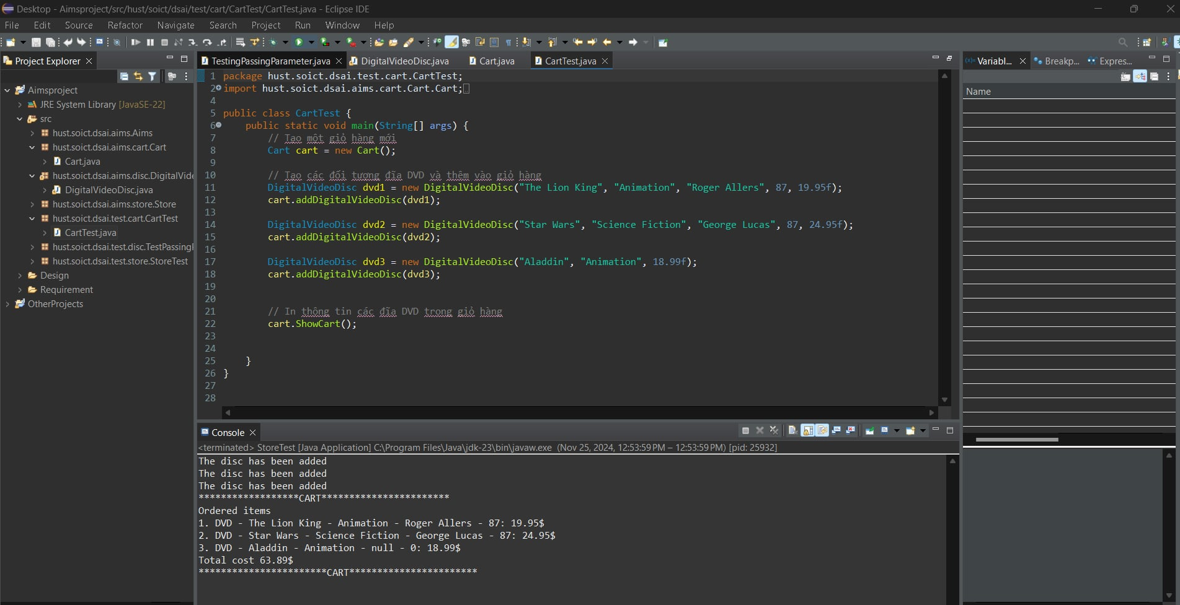

**Implement Store class**

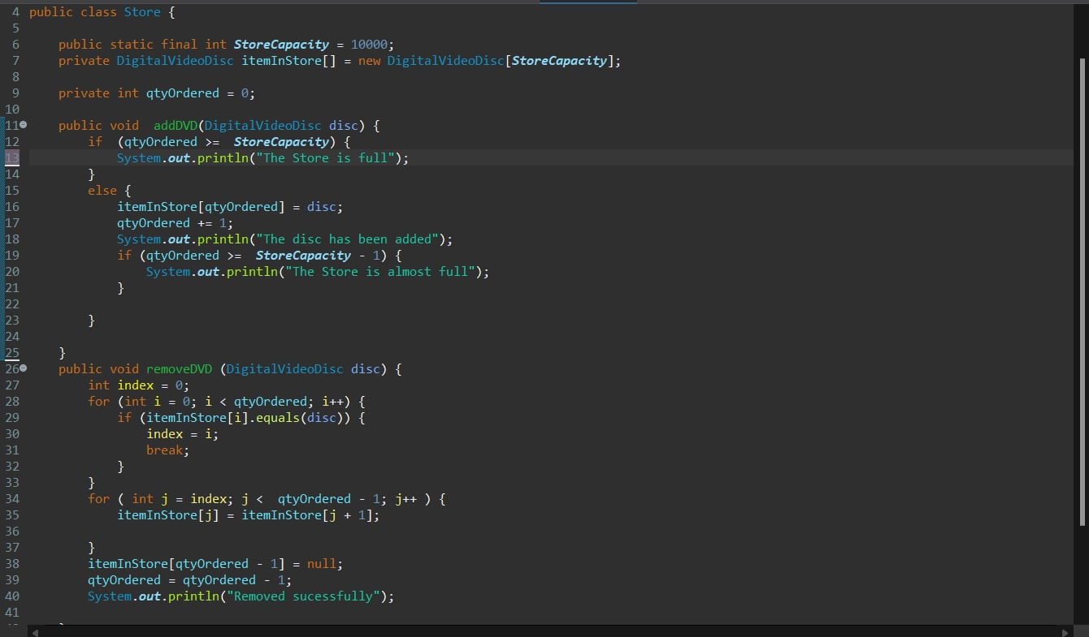

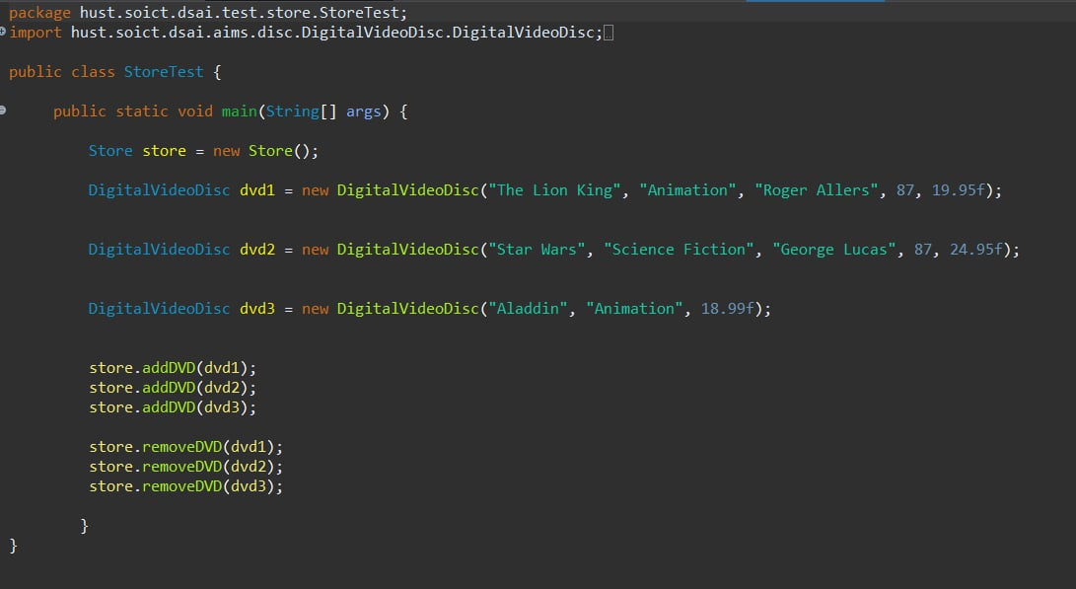

**String, StringBuilder and StringBuffer**

